Security

The LearningTree platform is hosted on a Microsoft Azure cloud environment in a high availability configuration. The Azure cloud platform provides several industry standard security certifications and disaster recovery policies as part of the architecture. A full description of the Microsoft Trust Center and Microsoft’s Security, Privacy and Compliance are available upon customer request. Microsoft Azure Cloud Security Certifications:
The LearningTree platform conforms to all the FERPA and Student Data Privacy policies. The security model of the platform is role-based and provides secure access to only the information that the user has “an educational need to know.”
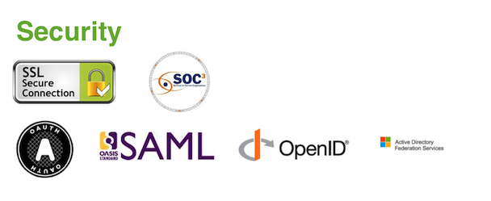
Since the platform provides role-based security access to the users in a Tenancy, all the application user identities and roles are carried forward from the customer Student Information System or Identity Providers such as Active Directory or LDAP. The platform supports several Identity Frameworks and Single Sign On Protocols based on customer needs. Here are some of the supported Security Protocols.
LearningTree is committed to safeguarding student and educator privacy and that is why LearningTree has signed the Student Privacy Pledge and is listed on the following webpage: http://studentprivacypledge.org/?page_id=22

LearningTree does not partner with any external vendors who will have access to the collection or housing of data. LearningTree does not absorb any ownership of any student level data collected from the district or users. LearningTree uses the Microsoft Azure platform, which provides unsurpassed levels of security and privacy when storing data as well as complying to FERPA and any PII data.
Here are our platform Privacy badges:

Role Based Security
Support multiple user types including but not limited to administrators, teachers, students and parents.

- The LearningTree platform is a FERPA compliant role-based system and provides multiple roles ranging from District Administrators, District Users, School Administrators, Teachers, Students and Parents
- Additional roles can easily be created and customized according to district needs

Integration Management
LearningTree platform supports integration with any third party application which supports either open standards, LTI Standards, SAML, Oauth, AD
We proposing to study SABS applications which are under integration scope as mentioned in requirement documents (Finance System, CRM System) and supported integration patterns/standards of application and execute the integration process to support the following integration use cases
- Customer Account Interface
- Product Interface
- Pricing Interface
- Payment Interface
- Customer Enquiries and Complaints

Here below is LearningTree Platform integration capabilities
Open Standards
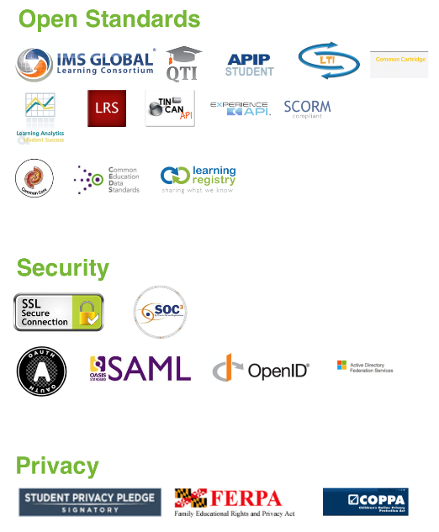
LearningTree platform supports parental access in two ways. We integrate with Infinite Campus SIS through SSO and provide a seamless interface for Parents to login and access the LMS with the roles and permissions carried forward from Infinite Campus. We also integrate the with Infinite Campus grade book for the course assignments and assessments. Further, if the district wishes to have a standalone solution for Parental access, we provide an OpenID solution where in the district would provide parents with an invitation to access the platform directly using any of the OpenID providers such as Microsoft, Google, Facebook, Twitter, etc.

IMS Integration Standards
LMS platform currently supports APIP and QTI formats. LearningTree is an IMS Global member and have active certifications for QTI, LTI and One Roster. We will plan to obtain AQTI certification when it is available. (https://site.imsglobal.org/certifications/LearningTree-inc/155666/LearningTree#cert_pane_nid_181511)

Content Management
- N/A
Assessment
- N/A
Pedagogy
- Adaptive Learning
- Visible Learning
Mapping with NEP

Approach & methodology.
Implementation Plan
LearningTree has successfully implemented LMS implementation, and utilizes a dedicated project manager, and the agile SCRUM framework to define a detailed implementation plan for the work to be completed:
Sprints (typically 1-week time-boxed intervals to deliver tasks)
Product backlogs to manage user stories and priorities and to breakdown user stories into defined deliverable tasks
Show times to present end-of-sprint results to achieve early engagement and review by key stakeholders
The LEARNINGTREE Project Manager, working in conjunction with the Customer Project Manager, will document a Communication Plan as part of the Master Project Management Plan.
The LEARNINGTREE Project Manager, working in conjunction with the Customer Project Manager, will compile weekly status reports for distribution to both Customer and LEARNINGTREE management.
Weekly status meetings will be held to review the project’s overall status, the acceptance of deliverables, the project schedule, and open issues noted in the status report.
LearningTree’s typical implementation schedule for large clients is based on a ‘30 day to operational readiness’ model. This means that LearningTree clients are typically up and running in 30 days.
While a detailed project plan will be defined with the client, the following represents a high-level overview of key elements. Some of the activities are completed in parallel.
1 | Project Kick-off (1 week from contract award)
2 | Define Detailed Project Plan (1 week from contract award)
3 | Establish data sharing configurations (1 week from contract award)
4 | State and local standards alignment and loading (2nd week)
5 | Assessment item bank integration and loading (2nd week)
6 | SSO integration and user provisioning (3rd week)
7 | Data integration and loading (3rd week)
8 | Deployment and rollout (4th week)
9 | Training (TBD)

Training Methodology
Successful and sustainable professional learning begins with client organization leadership engagement. Learningtree provides roll based training which includes administration, Course authors and Faculty.. LearningTree executes the training in a variety of options concerning professional development and training support in the following models described below.
Training Models:
1. On-site training to support the train the trainer model. LearningTree’s on-site “train the trainer” model is designed to build capacity and understanding of the software, enabling organization leaders and key members to re-deliver training to additional staff when appropriate. Recognizing that timing, readiness, and scheduling are all key factors in implementing new technology, our “train the trainer” staff development equips educators with engaging, interactive sessions that can be modelled and re-delivered to additional staff.
2. Virtual training with full day, half day, & hourly options on prioritized areas of focus. There are several options LearningTree has to offer regarding virtual training for districts. Virtual training works best after initial on-site training has occurred and is most effective when broken into singular areas of focus. Trainings can be offered as full day, half day, and hourly. Our website includes a wealth of webinars, tutorials, and resources at no additional cost. We can work with you to create a customized virtual training solution with an emphasis on sustainability and adoption.
3. Job-Embedded Professional Development opportunities connecting research- based practices with use of the system. Our Job-Embedded Professional Development opportunities connect districts with certified education consultants. LearningTree consultants work with organization leaders and key members to develop on-site training, blending best practices with use of the software. Job- Embedded PD can cover a variety of topics including PLCs, Assessments, Curriculum Planning, Student Engagement, Blended Learning, Data-Driven Instruction, Stakeholder Communication, and more!
Professional Learning Service Packages:
Two Day Package
Session | Topic | Objectives | Success Criteria
1 | Navigating the LearningTree Platform with Success | - Know how to navigate the LearningTree platform  - Know the powerful features available on the LearningTree platform | - Navigate the platform successfully, including assigning an assessment, creating a new assessment, etc.
2 | Introduction to Assessment and Evidence-Centered Design | - Identify and understand the purpose of different types of assessments and the outcomes expected for different assessments, including how this information is considered in the development of the assessments.  - learn the critical elements of evidence-centered design and how it is used to develop assessment tasks.  - Learn how clear descriptions of evidence to be gathered are used to craft tasks to assess academic standards, and practice writing tasks aligned to academic standards.  - Apply this learning to select items from the item bank and to draft assessment tasks aligned to academic standards. | - Determine which sample assessments provided are best suited for formative, interim, and summative purposes.  - Craft a formative assessment using evidence centered design elements (e.g. claims, ELA/Evidences/Math PLDs) and the provided item bank.
3 | Critical Elements of Formative Item Writing | - Practice writing items that are aligned to academic standards using ECD and review the items written by others to check for alignment. | - Craft questions (tasks) using evidence statements to create practice items.  - Review the questions (tasks) of peers for alignment.
4 | Principles of Universal Design | - Learn principles of universal design in item development, which helps ensure fairness and validity in assessment.  - Review how use of bias and sensitivity guidelines can support development of culturally responsive formative assessments and practice applying new learning to review items for use on a potential formative assessment. | - Review and revise formative assessments to better meet the principles of universal design.  - Review sample items using bias and sensitivity guidelines. Revise as needed to produce culturally responsive formatives.
5 | Using the curated item bank to support instructional planning | - Learn how to use the curated item bank, including how to select items from the bank to support curricular backwards design of lessons and how to create assessment forms that balance critical elements such as complexity and universal design. | - Use the curated item bank to plan a lesson.  - Use the curated item bank to create an end of unit assessment that balances complexity and other critical design elements for quality assessment forms.
6 | Using data from interims to make instructional decisions | - Learn how to use the data from interims/benchmarks to make instructional decisions (with a focus on providing tier 1 supports based on data). | - Use the reports from interim/benchmark assessments to plan for successful implementation of tier 1 supports and next steps in curriculum implementation.

One Day Package
Session | Topic | Objectives | Success Criteria
1 | Navigating the LearningTree Platform with Success | - Know how to navigate the LearningTree platform  - Know the powerful features available on the LearningTree platform | - Navigate the platform successfully, including assigning an assessment, creating a new assessment, etc. [NOTE—CP and LearningTree to develop this session jointly]
2 | Using the curated item bank to support instructional planning | - Learn how to use the curated item bank, including how to select items from the bank to support curricular backwards design of lessons and how to create assessment forms that balance critical elements such as complexity and universal design. | - Use the curated item bank to plan a lesson.  - Use the curated item bank to create an end of unit assessment that balances complexity and other critical design elements for quality assessment forms.
3a* | Using data from interims to make instructional decisions | - Learn how to use the data from interims/benchmarks to make instructional decisions (with a focus on providing tier 1 supports based on data). | - Use the reports from interim/benchmark assessments to plan for successful implementation of tier 1 supports and next steps in curriculum implementation.
3b* | Critical Elements of Formative Item Writing | - Practice writing items that are aligned to academic standards using ECD and review the items written by others to check for alignment. | - Craft questions (tasks) using evidence statements to create practice items.  - Review the questions (tasks) of peers for alignment.
* NOTE – either 3a or 3b (not both) will be included in the one-day package based on the needs of the client

Half Day Package – follow on option to the above one/two-day packages
Session | Topic | Objectives | Success Criteria
1 | How to Use and Interpret Data from reports | - Understand how to use and interpret data from the LearningTree reports | - The ability to use the data and make instructional decisions in the classroom

Quality framework
Support Model
Level Agreements and Service Credits (Warranty)
All the customer instances of LearningTree are actively monitored end-to-end for health and high-availability as we continually strive to exceed our uptime SLA of 99.9%. In the event of LearningTree not meeting the “monthly uptime” SLA in a subscription month, LearningTree will provide service credits of 5% of the pro-rated monthly subscription license fee.
The LearningTree “monthly uptime” calculation is based on
- “Maximum Available Time” – the total number of minutes that the LearningTree solution has been deployed for a customer billed subscription month
- “Downtime” – the total accumulated minutes for a customer billed subscription month during which the LearningTree solution is unavailable. A minute is considered unavailable if all continuous attempts by customer to establish a connection to the solution within the minute fail.
- “Uptime Percentage” – is calculated as Maximum Available Minutes less Downtime divided by Maximum Available Minutes in the subscription month. This is represented by the following formula:
Uptime% = (Maximum Available Minutes – Downtime) / Maximum Available Minutes
The LearningTree platform is externally monitored by Pingdom; The uptime can be accessed through the following link: http://status.LearningTree.com/
Support Plan
Customer Support Services
LearningTree is committed to providing the best customer service, support and training for its customers. The key to successful implementation is targeted support and timely professional development. LearningTree provides user support in multiple formats including on-site, phone, email and online support; providing a flexible model to support district needs.
- Live chat with LearningTree representatives during business hours.
- 24/7, access to online support modules to include all materials used in on- site training, best practices, train-the trainer models, and instructional videos.
- Customer Support email/phone/ticket submissions with 24-hour response time
- Designated Success Coach to work with district and provide implementation and on-going support.
- 24/7 Support and Help provided on a need basis. The district will have a dedicated Project manager to support the district along with district leaders. LEARNINGTREE support response protocol is outlined below.
Service Request Management
Issues will be categorized and handled according to an assigned severity level. The case severity level is selected by the User at time of case submission, and will be updated by LEARNINGTREE as follows:

Level 1 – Critical | Critical production issue affecting all users, including system unavailability and data integrity issues with no workaround available.
Level 2 – Urgent | Major functionality is impacted, or performance is significantly degraded. Issue is persistent and affects many users and/or major functionality. No reasonable workaround is available. Also includes time-sensitive requests such as requests for feature activation or a data export.
Level 3 – High | System performance issue or bug affecting some but not all users. Short-term workaround is available, but not scalable.
Level 4 – Medium | Inquiry regarding a routine technical issue; information requested on application capabilities, navigation, installation or configuration; bug affecting a small number of users. Reasonable workaround available. Resolution required as soon as reasonably practicable.

LEARNINGTREE will use commercially reasonable efforts to respond to each case within the applicable response time described in the table below, depending on the severity level set on the case.

Severity Level | Target Initial Response Time
1 | 2 Hour
2 | 4 Hour
3 | 24 hours
4 | 2 - 3 days

Severity Level 1 and 2 target initial response times is 24x7, including weekends and holidays. Severity Level 1 cases must be submitted via telephone as described above. Severity Level 1 and 2 target initial response times does not apply to cases submitted via email.
Severity Level 3 and 4 target initial response times include local business hours only and exclude weekends and holidays, and do not apply to cases submitted via e-mail.
Reproducible errors that cannot promptly be resolved will be escalated to higher support tiers for further investigation and analysis. LEARNINGTREE must be able to reproduce errors in order to resolve them. Customer agrees to cooperate and work closely with LEARNINGTREE to reproduce errors, including conducting diagnostic or troubleshooting activities as requested and appropriate. Also, subject to Customer’s approval on a case-by-case basis, Users may be asked to provide remote access to their LEARNINGTREE application and/or desktop system for troubleshooting purposes.

